|  |  |
| --- | --- |
| **Assignment Case** |  |
| COMP6708016 Object Oriented Programming |
| **Computer Science** | **E223-COMP6708016-LS00209-01** |
| ***Valid on*** *Even Semester Year 2021/2022* | **Revision 00** |

## Soal

*Case*

**My Phone Contact**

**My** **Phone** **Contact** is a program that can be used to manage contacts contained in the Phone. There are several features provided by this system such **as view all contacts**, **add contacts**, **delete contacts**, and **search contacts.** They ask you to make a simple program to help them manage the list using **JAVA programming language** with **Object** **Oriented** **Programming** concepts such as **Encapsulation, Composition,** and **Aggregation**.

* First, the program will ask the user to set the phone information:

1. The program will ask user to input the **owner’s name**. Validate the **owner’s name** must **starts with “Mr.”, or “Mrs.”**.
2. The program will ask user to input the **phone type**. **Validate** that **phone type** mustbe **either “Work”, “Home”, or “Mobile” (case insensitive)**.
3. The program will ask user to input **storage contact**. **Validate** the storage must be **between** **1 and 20** **(inclusive).**

1. The program will **generate** the **contact phone number** by using the following format below:

**Phone Number: 08XXXXXXXXXX**

**X: 10 digits of random** **number** [**0-9**]

e.g.

**082761938873**

* After that, the user will be redirected to **main** **menu** page. The program will have 5 menu items:

1. **View All Contact**
2. **Add Contact**
3. **Delete Contact**
4. **Search Contact**
5. **Exit**

* If the user selected **menu 1 (View All Contact)**:
  + If there’s no **contact** **available**, the program will **show** **following** **message**. Then, return to **main menu**.



* + **Otherwise**, show all **contacts’** **details** including **Name**, **Phone Number**, and **Email**.

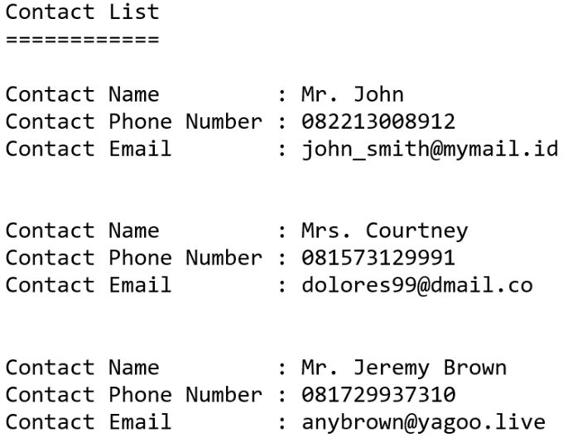

* If the user selected **menu 2 (Add Contact)**:
  + **Check** if the user’s phone contact storage is **already full**. Then, **show** **following** **message** and redirect to **main menu**.



* + **Otherwise**, the program will proceed to ask user to input following information:
    - **Contact name**

Validate the **value** must **starts with “Mr.”, or “Mrs.”**.

* + - **Phone number**

Validate the **value must accept numbers only**, and the **length is equal to** **12 characters long**.

* + - **Email**

Validate the **value** must follows following conditions:

* May contain **only** **1** ‘**@**’ (at) character.
* May contain **at least** ‘**.**’ (dot) character.
* ‘**.**’ (dot) and ‘**@**’ (at) character must **not** be **put side-by-side together**.

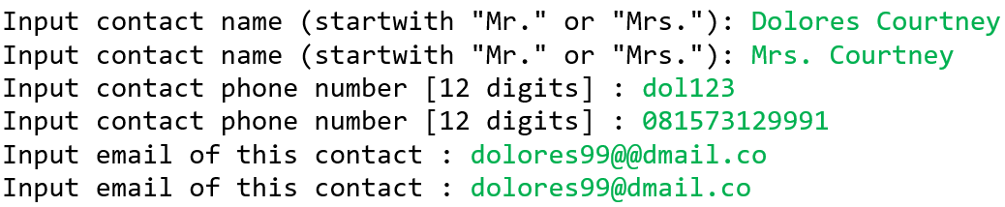

* + Then, the program will **save** all **contact’s information** into a **list (ArrayList / Vector / Array)**.
  + Finally, **update the phone contact storage** by increasing the number by **1**. Then, return to **main menu**.
* If the user selected **menu 3 (Delete)**:
  + If there’s no **contact** **available**, the program will **show** **following** **message**. Then, return to **main menu**.



* + **Otherwise**, show all **contacts’** **details** including **Name**, and **Phone Number**.
  + The program will ask the user to **select** **which contact to be removed**. Validate the **value** must be **between 1 and** **total contact data**.
  + Then, the program will **remove the selected contact** from **contact list**.
  + Finally, **update phone’s contact storage** by **decreasing the number by 1**. Then, return to **main** **menu**.

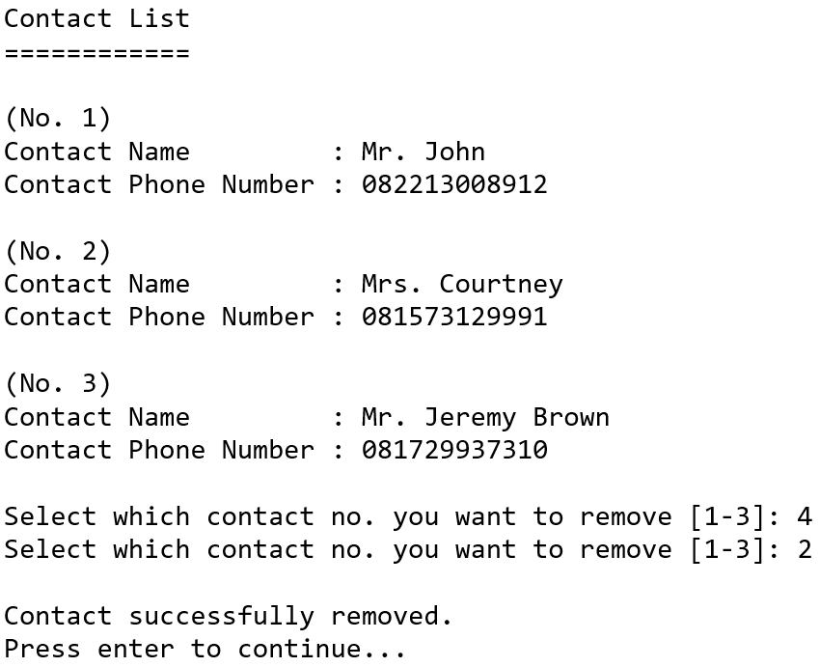

* If the user selected **menu 4 (Search Contact)**:
  + If there’s no **contact** **available**, the program will **show** **following** **message**. Then, return to **main menu**.



* + **Otherwise**, the program will ask user to input **contact name as the search term**. Validate the **value cannot be empty**.
* The program will display the **list of** **contacts** **who’s** **its** **name** **contains** the **inputted** **search** **term**.

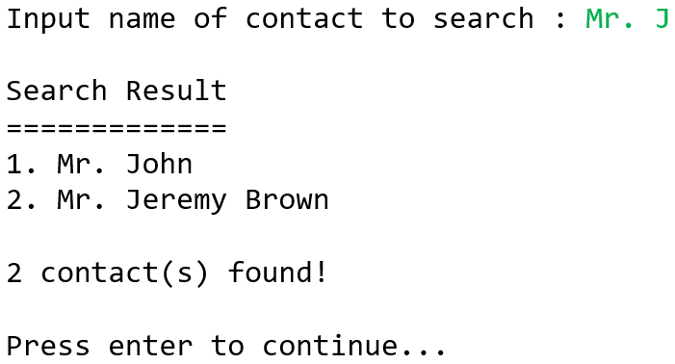

* If the user selected **menu 5 (Exit)**. The program will **exit**.

**If you need any assistance, kindly ask your assistants for help.**